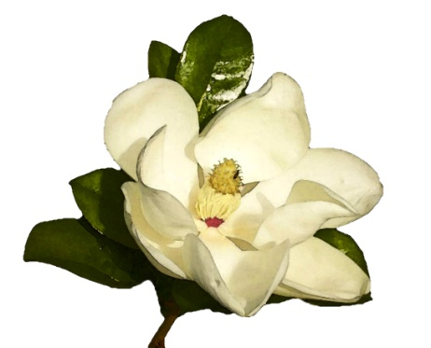
Personal Information
Name
Husband’s Name
Address
Mailing Address
Home Phone Cell Phone:
E-mail Address
Birthday (Year Optional)
Please Circle
Mail Email Do you wish to receive District IV Newsletter by mail or email?
Yes No Would you like a binder for your CGC Yearbook? If yes, what flower would you like to have on the front of your binder? You can have the magnolia (as shown above) or another flower of your choice _____________________________________________ (The binder with flower and your name is $7.50. Make check out to Columbus Garden Club and please give check to Andrea Utz (CGC Treasurer). Velma Harrington will print your personalized yearbook binder.)
Yes No Would you like to have a Columbus Garden Club member mentor you during your first year of
membership? (Your mentor would answer questions you may have about Columbus Garden
Club, help you get involved in club activities, and introduce you to other club members.)

Previous Garden Club Information
Yes No Have you ever been a member of a garden club
Which one(s):
Yes No Have you ever held an office or been a president of a garden club?
Which office(s):
Which garden club(s)?
Yes No Are you a Master Gardener?
Yes No Do you have any other gardening certification?
If so, what and where did you receive your certification?
Yes No Are you a member of the American Horticultural Society
Yes No Are you a member of the American Rose Society?
Yes No Are you a member of the American Hemerocallis Society?
Yes No Are you a member of any other Horticultural Societys?

Do you have a special interest or knowledge in a certain type of gardening or in a specific species of plants that you would like to share with our group? If so, what?

The objectives of the Columbus Garden Club is to stimulate the knowledge and love of gardening among amateurs, to aid in the protection of native trees, plants, birds and to encourage civic horticulture. Any person interested in supporting these objectives and willing to pay the annual dues may become a member. Active Members are expected to attend meetings and accept assignments on committees and programs.

Signed: Date:
Please Mail to : CGC; PO Box 1222; Columbus, Tx, 78934 with yearly dues ($25.00) OR bring it to the next meeting.

