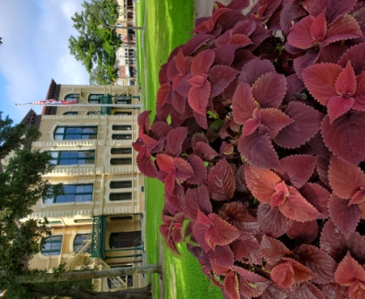
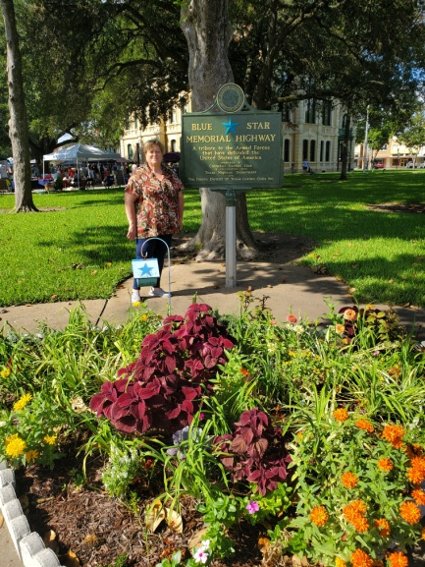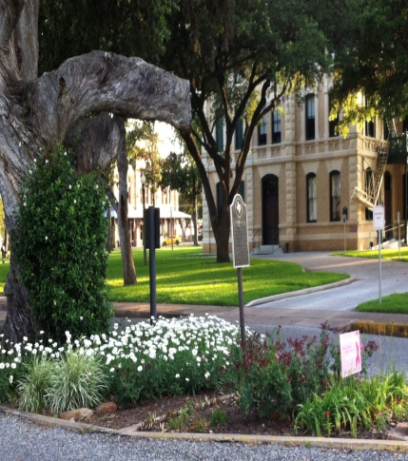
Garden Club committees maintained plantings around the Courthouse Square during the long hot summer. Courthouse Planters (Left): Marilyn Tanner, Sharon Wegenhoft, Pawne Blomquist, Sharon Roensh, Brenda Boehm, Debbie Braden, Lynda Counts, Janet Johnson and Velma Harrington Blue Star Memorial Garden (center): Sandy Barrett, Court Oak Bed – Plant it Pink (Right): Marian Schonenberg and Sharon Wegenhoft
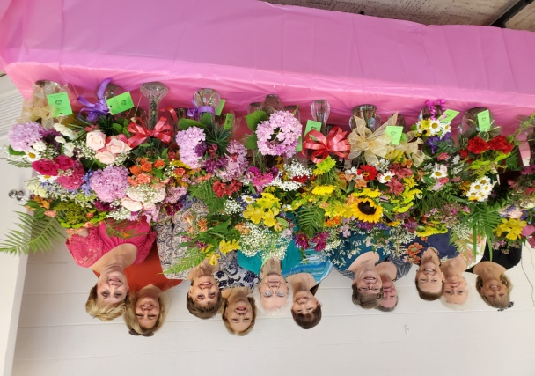
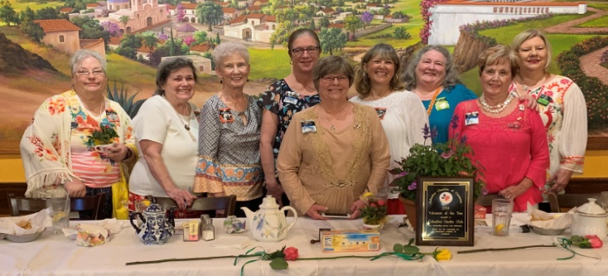
Velma Harrington, Brenda Boehm, Pawne Blomquist, Sharon Wegenhoft, Lyn Buescher, Marian Schonenberg, Debbie Braden, Cheryl Rose, Lana Miller, Sharon Roensch, Janet Johnson
2019-2020 Officers were installed in May and worked throughout the summer to plan a year full of gardening programs and projects. (l-r) Chris Schobel, Andrea Utz, Martha Jordan, Regina Williamson, Debbie Braden, Janet Johnson, Cheryl Rose, Velma Harrington, Sharon Wegenhoft (not pictured – Susan Peletz)
September, 2019
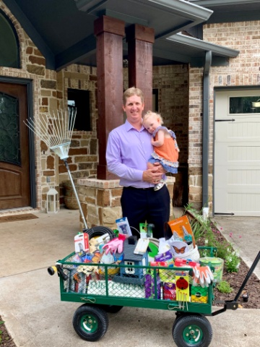
2019 Scholarship Wagon Won
Russell Braun won the scholarship wagon at the 2019 Columbus Garden Club Plant Sale. The wagon was donated by McCoys in Weimar. Items in the wagon included potting soil, yard art, watering hose, bird feeder, gardening tools and many gardening items.
Cynthia Medina, graduate of Columbus High School, was the winner of the 2019 scholarship. Cynthia will be attending Texas A&M in the Fall and will be a biology major.
Ericka Braun was chairman of the scholarship committee. Committee members were: Emily Lewis and Susan Peletz.
National Garden Week Observed - Columbus Garden Club members gathered together June 6 to arrange flowers in observance of National Garden Week. Proclamations were signed in observance of the event by Commissioners Court at the County Courthouse and by City Council at City Hall. Some children who were participating in sewing class at the Ag Center enjoyed putting together some arrangements too. After the flowers were arranged, members distributed them to city and county offices, Columbus Community Hospital, several nursing homes, newspaper offices, numerous offices and to members of the Columbus community.
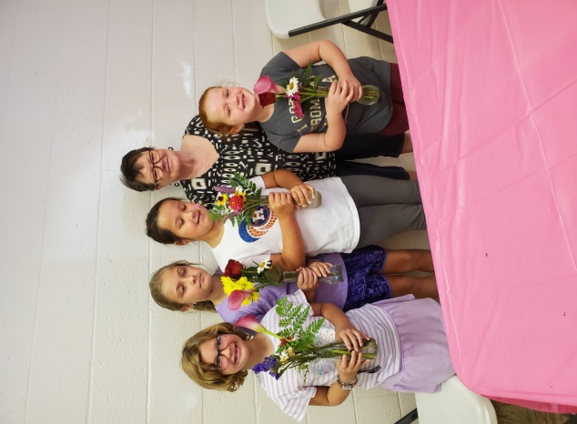
We had helpers putting together flower arrangements for National Garden Week
……………………and we had proclamation signings.
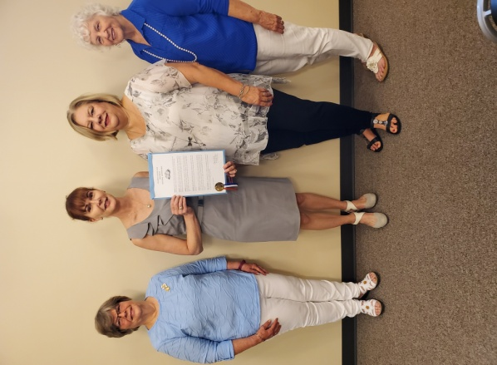
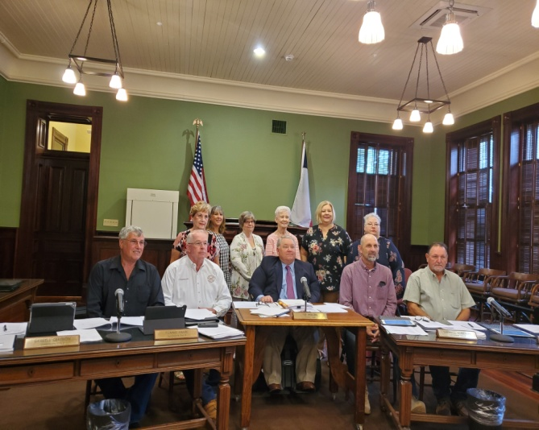
Judge Ty Prause (front center) signed proclamation for National Garden Week during the Commissioners Court. Garden Club members in attendance are (l-r) Velma Harrington, Janet Johnson, Debbie Braden, Martha Jordan, Sharon Wegenhoft, and Chris Schobel.
Sandy Carr leads a sewing group at Colorado County Ag Bldg. Some of the children who came to sew were excited to help put together flower arrangements.

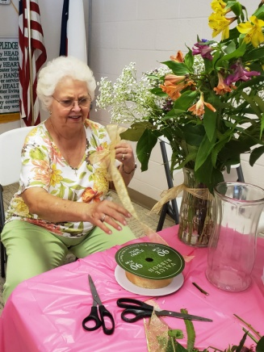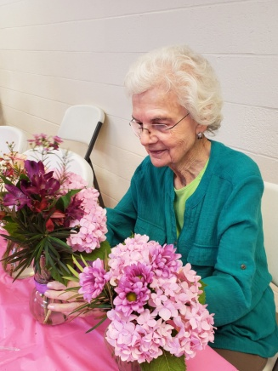
Mayor Lori An Gobert signed proclamation during City Council meeting. (l-r) Debbie Braden, Mayor Gobert, Sharon Wegenhoft, and Joann Obenhaus
So Much Fun….Sharon Roensch puts her masterful touch making bows for the arrangements. Lyn Buescher adds her flower arranging talents to make “flower show worthy” creations.

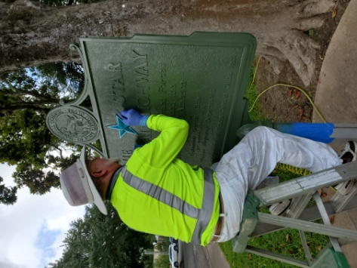
Blue Star Memorial Refurbished
In May the Blue Star Memorial marker was refurbished through a grant from CCIDC (Colorado County Industrial Development Corp.). The Colorado County Citizen highlighted the event on the front page of the newspaper including historical information provided by Columbus Garden Club.
Tom Stelling of Historical Markers Restoration arrived on the square May 23 to refurbish the Blue Star Marker that was dedicated on the northeast corner of the courthouse square Feb. 2, 1957.

Yard of the Month Committee Busy During the Summer Months
June July August
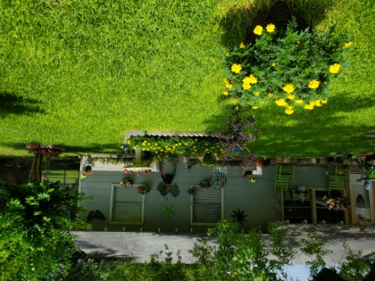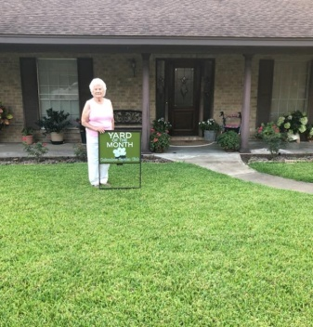
June – Home of Rev. Ervin and Ardie Mayberry at 1703 Rampart Street July – Home of Mrs. Ernestine Henneke at 102 Krupka Street August – Home of Larry and Linda Petter, 1304 Travis Street
Thanks to Sandy Barrett who is chairman of the Yard of the Month Committee and to the members of the committee - Lyn Buescher, Margaret Miller, and Charlene Morrison.

