The Magnolia
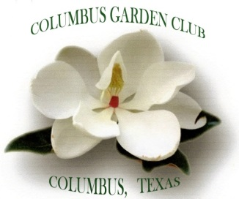

Newsletter of Columbus Garden Club
November 8, 2017

Celebrating Years Growing Green

Good morning ladies. Our program for day is “Planning a Flower Show” by Regena Williamson, Dist. IV Board of Directors, Houston Flower Show Judge, Past President and current Treasurer of Halletsville Garden Club, member of Cloumbus Garden.

Would like to thank our November Hostess: Randa Simmons, Sandy Chalouka, Andrta Utz, Beth Easterling, Mary Edwards, Chris Schobels.

When you are out and about go by The Midtown Park Butterfly Garden, it looks awesome! Would like to thank Mary Jane, Debbie Braden, Janice Neumann, Robbie Showers, Lynn Showers for all the hard work pulling weeds and planting new plants.

The next meeting will be November 8, 2017, the program will about Planning a Flower Show by Regena Wiliamson.

October 23 will be decorating the Courthouse Lawn for fall.

The November hostesses: Randa Simmons, Sandy Chalouka, Andrea Utz, Beth Easterling, Mary Edwards, Chris Schobel.

Next meeting is November 8

Be safe, God Bless

